9. We have loaded ***Auto*** dataset from ***ISLR*** library.

(a) **Quantitative predictors:** mpg, cylinder, displacement, horsepower, weight, acceleration, year.

**Qualitative predictors:** origin, name

(b)

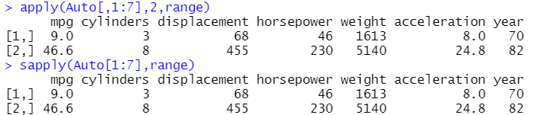

apply() needs 2 in middle for column calculation, sapply() automatically involves calculation for columns.

(c)

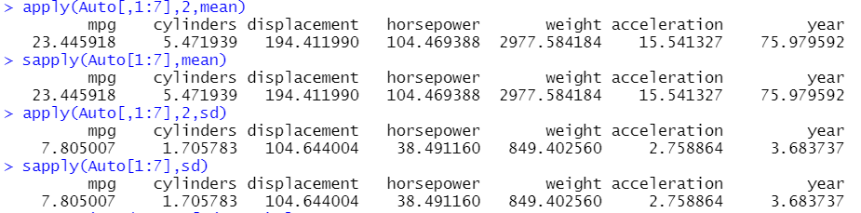

(d)



We have successfully omitted 10th through 85th observation.

(e)

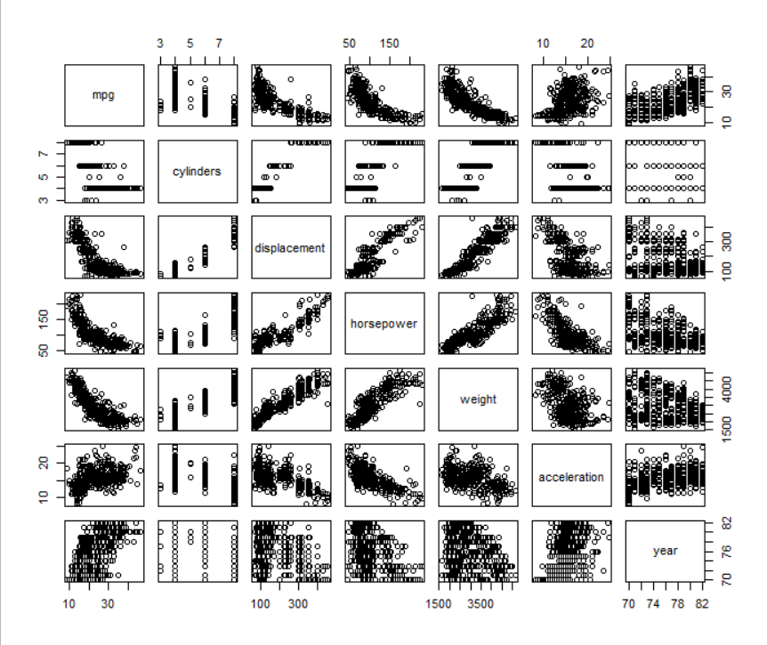

mpg has strong negative correlation with displacement, horsepower, weight, and, mpg has positive correlation with year, i.e., new models increase mpg than older models.

(f)

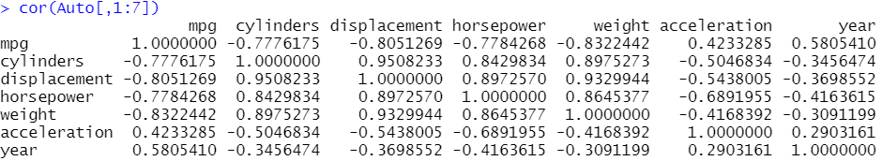

From the correlation matrix, we can see that we can predict mpg. As cylinders, displacement, horsepower, weight increase, mpg will decrease and as acceleration increases mpg increases, and new models will have higher mpg.